Documents
- A Form 1099-R for a Traditional to Roth IRA Conversion should have Code 2 in box 7 if the participant is under age 59½ or Code 7 if the participant is at least age 59½ and the IRA/SEP/SIMPLE box checked.
- The amount converted is taxable income, but a Code 2 distribution is not subject to the additional 10% early distribution tax.
- Emphasize need to look at Box 7 at interview stage to determine if in scope!
- Caution: Code 2 can be used for other distributions, e.g. distribution to a Public Safety Officer after age 59 1/2
Entry into TSO
- Complete the 1099-R that contains the Code 2 or Code 7.
- Search for Form 8606 and enter the amount converted in the sixth box.
- If the traditional IRA had a basis, also complete Part 1 of Form 8606. Taxpayer must have Form 8606 from a previous year return. See page D-35 of the NTTC Modified Pub 4012.

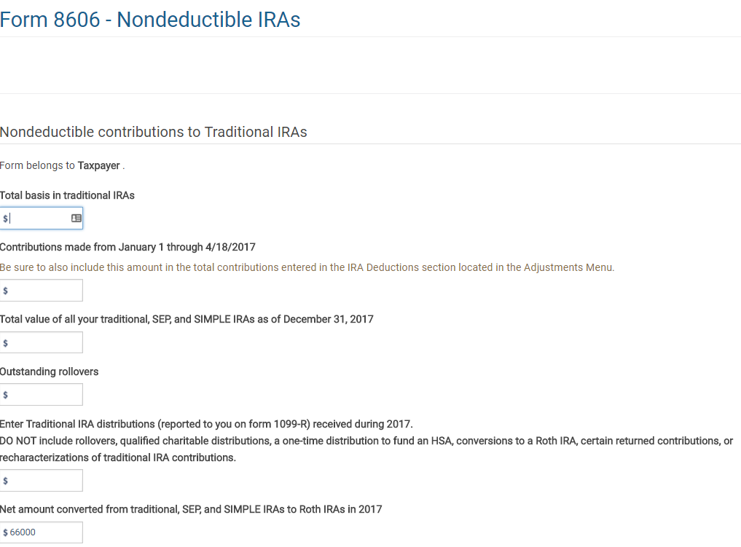
Enter the amount of the distribution from the traditional IRA that was converted to a Roth IRA

Print PDF of form 8606. Part II should look like this:
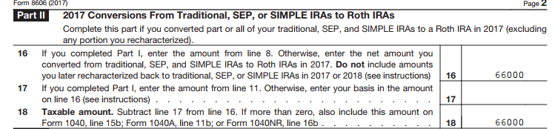
The amount on line 18 goes to the 1040 line 15b and is taxable.

